**EXPERIMENT # 14**

**Aim: Study and Perform the Norton’s Theorem on Given Circuit**

**Apparatus:**

1. Resistors (fixed and variable)
2. Multi-meter
3. Jumper Wires
4. Breadboard
5. DC Supply

**Procedure:**

1. Measure four resistors and construct a circuit as shown below.

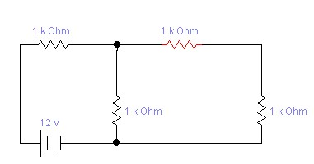

1. The specific set of points is 1 & 2, with respect to which, the Norton equivalent circuit has to be drawn.
2. Measure and note source voltage, V12 and I12 for different source voltages.

For 12 volt battery source

**V**

**12**

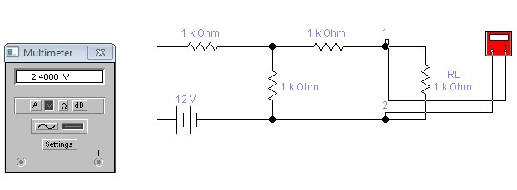

**I**

**12**

For

**5**

volt battery source

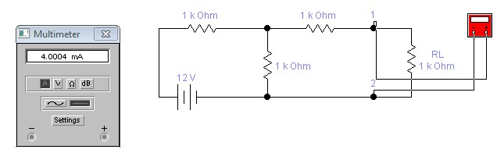

**V12**

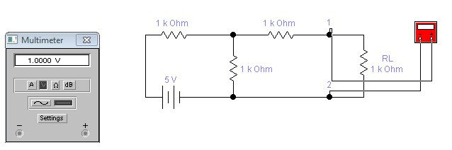

**I**

**12**

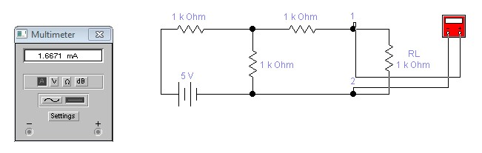

For **9** volts battery source

**V12**

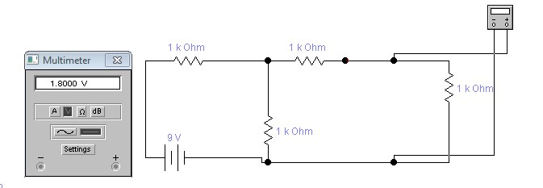

**I12**

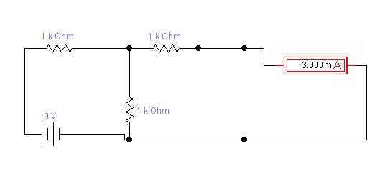

1. Remove resistance RL and replace it with a short circuit and measure current through terminals 1 and 2 for different values of source voltage (used in point 2 above) as shown below. This current is the Norton current In.

**In** for 12 volt battery source:

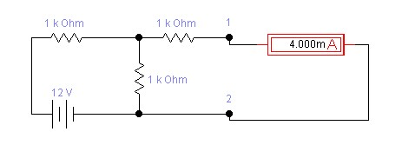

**In** for **5** volt battery source:

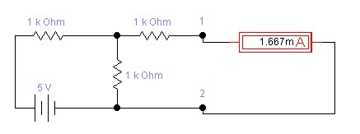

**I**

**n**

for 9 volt battery source:

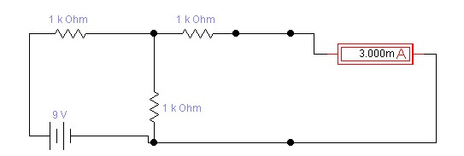

1. Turn off supply and place a short circuit across voltage source as shown below. Measure the resistance which is Norton equivalent resistance Rn

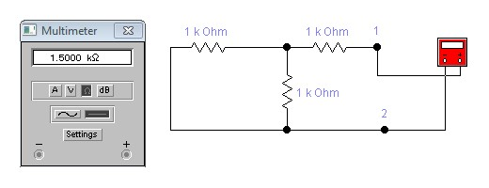

1. The Norton equivalent circuit is shown below:

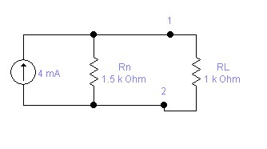

1. As a current source with a parallel resistance can be converted to an equivalent voltage source in series with a source resistance, the same circuit can be redrawn as shown below:

R

n

R

L

1

2

V

n

= I

n

x R

n

1. Measure V12 and I12 in the circuit drawn in point 6 above and compare with the results obtained in 2 above.

**Norton Equivalent Circuits:**

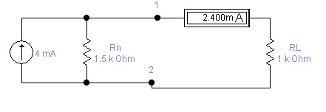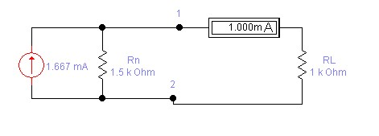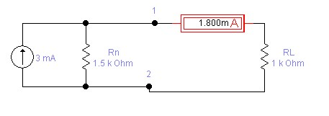

**Verification:**

|  |  |  |  |  |  |  |  |  |
| --- | --- | --- | --- | --- | --- | --- | --- | --- |
| **S.**  **No.** | **Source voltage**  **(Volt)** | **Measurements in Original Circuit** | | **Norton Equivalent Values** | | | **Measurements in**  **Norton Equivalent Circuit** | |
| **V12**  **(V)** | **I12**  **(mA)** | **In**  **(mA)** | **Rn (kΩ)** | **Vn = In x Rn**  **(V)** | **V12**  **(V)** | **I12**  **(mA)** |
| **1.** | **12** | **2.4** | **2.4** | **4** | **1.5** | **6** | **2.39** | **2.41** |
| **2.** | **5** | **1.0** | **1.0** | **1.667** | **1.5** | **2.5005** | **1.01** | **1.01** |
| **3.** | **9** | **1.8** | **1.8** | **3.0** | **1.5** | **4.5** | **1.81** | **1.81** |

**Lab Task Objective**

To find Norton equivalent and to find current between A and B

**Strategy**

We apply Norton theorem to find Norton equivalent.

# Procedure

* We shorted the point AB.
* Total resistance was found(by Resistance laws).
* Total current was found(by V=IR formula).
* Current across AB was found(by using parallel current formula) • Battery source was removed and Norton resistance was found.
* Current result across AB and Norton resistance and the shorted resistance(across which current was to be found) were put in parallel
* This was Norton Equivalent
* Finally total current was found by parallel current law. • This is our required current.

**Procedure detailed view(by screen shots)**

# Original Circuit

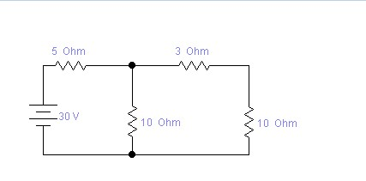

# Shorting A-B Terminal

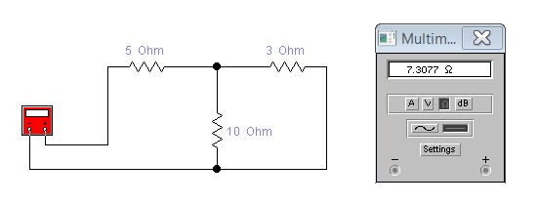

# Total current

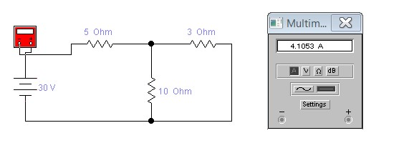

# Current at point A and B

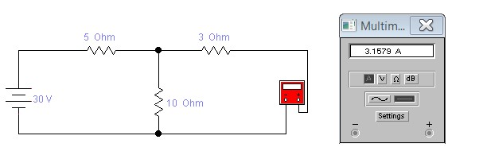

# Norton Resistance

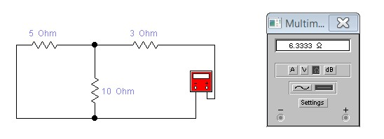

# Norton Equivalent Circuit

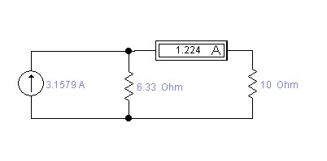

# Verification

|  |  |  |  |  |  |  |  |  |
| --- | --- | --- | --- | --- | --- | --- | --- | --- |
| **S.**  **No.** | **Source voltage**  **(Volt)** | **Measurements in Original Circuit** | | **Norton Equivalent Values** | | | **Measurements in**  **Norton Equivalent Circuit** | |
| **V12**  **(V)** | **I12**  **(A)** | **In**  **(A)** | **Rn (Ω)** | **Vn = In x Rn**  **(V)** | **V12**  **(V)** | **I12**  **(A)** |
| **1.** | **30** | **12.4** | **1.224** | **3.1579** | **6.33** | **19.989** | **12.25** | **1.225** |